

26

Rechnen mit Geldbeträgen

**Stimmt dein Wechselgeld?**

Du hast Durst und 10 € dabei.

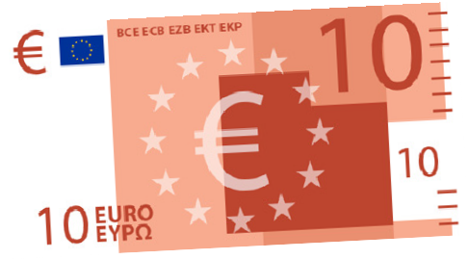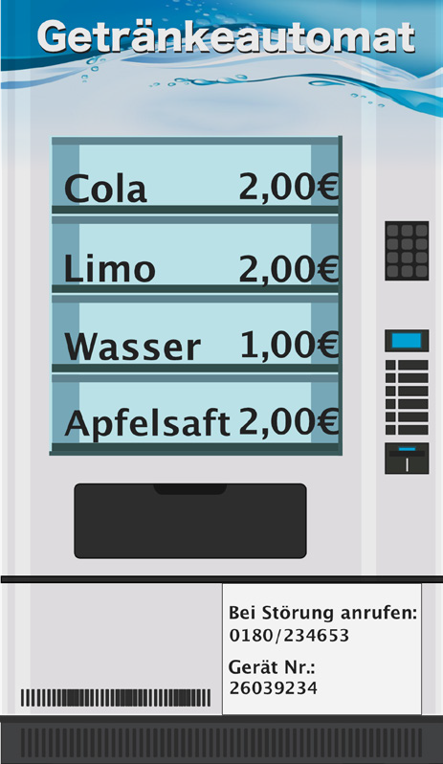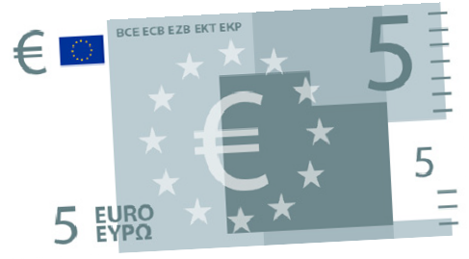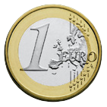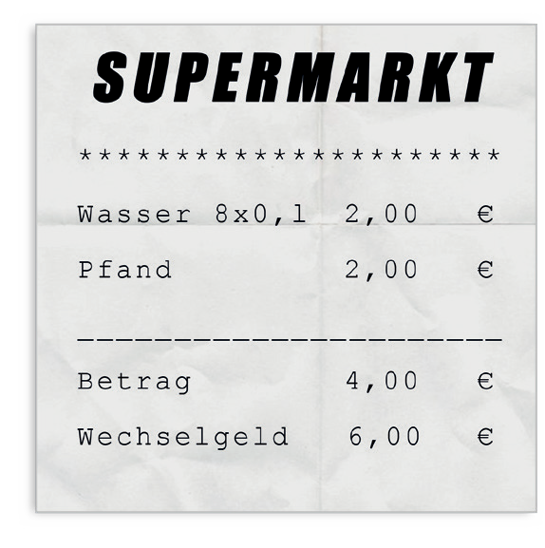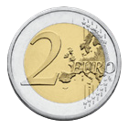

Wie viel Geld bekommst du nach deinem Einkauf zurück? Rechne das Wechselgeld nach.

1. >> 1 Wasser + 1 Limo

**Wechselgeld**

**>>**

|  |  |  |  |  |  |  |  |  |  |  |  |  |  |  |  |  |  |  |  |  |  |  |  |  |  |  |  |  |  |  |  |  |  |  |
| --- | --- | --- | --- | --- | --- | --- | --- | --- | --- | --- | --- | --- | --- | --- | --- | --- | --- | --- | --- | --- | --- | --- | --- | --- | --- | --- | --- | --- | --- | --- | --- | --- | --- | --- |
|  |  |  |  |  |  |  |  |  |  |  |  |  |  |  |  |  |  |  |  |  |  |  |  |  |  |  |  |  |  |  |  |  |  |  |
|  |  |  |  |  |  |  |  |  |  |  |  |  |  |  |  |  |  |  |  |  |  |  |  |  |  |  |  |  |  |  |  |  |  |  |
|  |  |  |  |  |  |  |  |  |  |  |  |  |  |  |  |  |  |  |  |  |  |  |  |  |  |  |  |  |  |  |  |  |  |  |
|  |  |  |  |  |  |  |  |  |  |  |  |  |  |  |  |  |  |  |  |  |  |  |  |  |  |  |  |  |  |  |  |  |  |  |
|  |  |  |  |  |  |  |  |  |  |  |  |  |  |  |  |  |  |  |  |  |  |  |  |  |  |  |  |  |  |  |  |  |  |  |
|  |  |  |  |  |  |  |  |  |  |  |  |  |  |  |  |  |  |  |  |  |  |  |  |  |  |  |  |  |  |  |  |  |  |  |
|  |  |  |  |  |  |  |  |  |  |  |  |  |  |  |  |  |  |  |  |  |  |  |  |  |  |  |  |  |  |  |  |  |  |  |
|  |  |  |  |  |  |  |  |  |  |  |  |  |  |  |  |  |  |  |  |  |  |  |  |  |  |  |  |  |  |  |  |  |  |  |
|  |  |  |  |  |  |  |  |  |  |  |  |  |  |  |  |  |  |  |  |  |  |  |  |  |  |  |  |  |  |  |  |  |  |  |

1. **Wechselgeld**

**>>**

|  |  |  |  |  |  |  |  |  |  |  |  |  |  |  |  |  |  |  |  |  |  |  |  |  |  |  |  |  |  |  |  |  |  |  |
| --- | --- | --- | --- | --- | --- | --- | --- | --- | --- | --- | --- | --- | --- | --- | --- | --- | --- | --- | --- | --- | --- | --- | --- | --- | --- | --- | --- | --- | --- | --- | --- | --- | --- | --- |
|  |  |  |  |  |  |  |  |  |  |  |  |  |  |  |  |  |  |  |  |  |  |  |  |  |  |  |  |  |  |  |  |  |  |  |
|  |  |  |  |  |  |  |  |  |  |  |  |  |  |  |  |  |  |  |  |  |  |  |  |  |  |  |  |  |  |  |  |  |  |  |
|  |  |  |  |  |  |  |  |  |  |  |  |  |  |  |  |  |  |  |  |  |  |  |  |  |  |  |  |  |  |  |  |  |  |  |
|  |  |  |  |  |  |  |  |  |  |  |  |  |  |  |  |  |  |  |  |  |  |  |  |  |  |  |  |  |  |  |  |  |  |  |
|  |  |  |  |  |  |  |  |  |  |  |  |  |  |  |  |  |  |  |  |  |  |  |  |  |  |  |  |  |  |  |  |  |  |  |
|  |  |  |  |  |  |  |  |  |  |  |  |  |  |  |  |  |  |  |  |  |  |  |  |  |  |  |  |  |  |  |  |  |  |  |
|  |  |  |  |  |  |  |  |  |  |  |  |  |  |  |  |  |  |  |  |  |  |  |  |  |  |  |  |  |  |  |  |  |  |  |
|  |  |  |  |  |  |  |  |  |  |  |  |  |  |  |  |  |  |  |  |  |  |  |  |  |  |  |  |  |  |  |  |  |  |  |
|  |  |  |  |  |  |  |  |  |  |  |  |  |  |  |  |  |  |  |  |  |  |  |  |  |  |  |  |  |  |  |  |  |  |  |

**Stimmt dein Wechselgeld?**



Bildnachweis: Deutsche Bundesbank: Euro-Banknoten; Kiosk Verkäufer: © Bukavik/Shutterstock.com

27

**3**

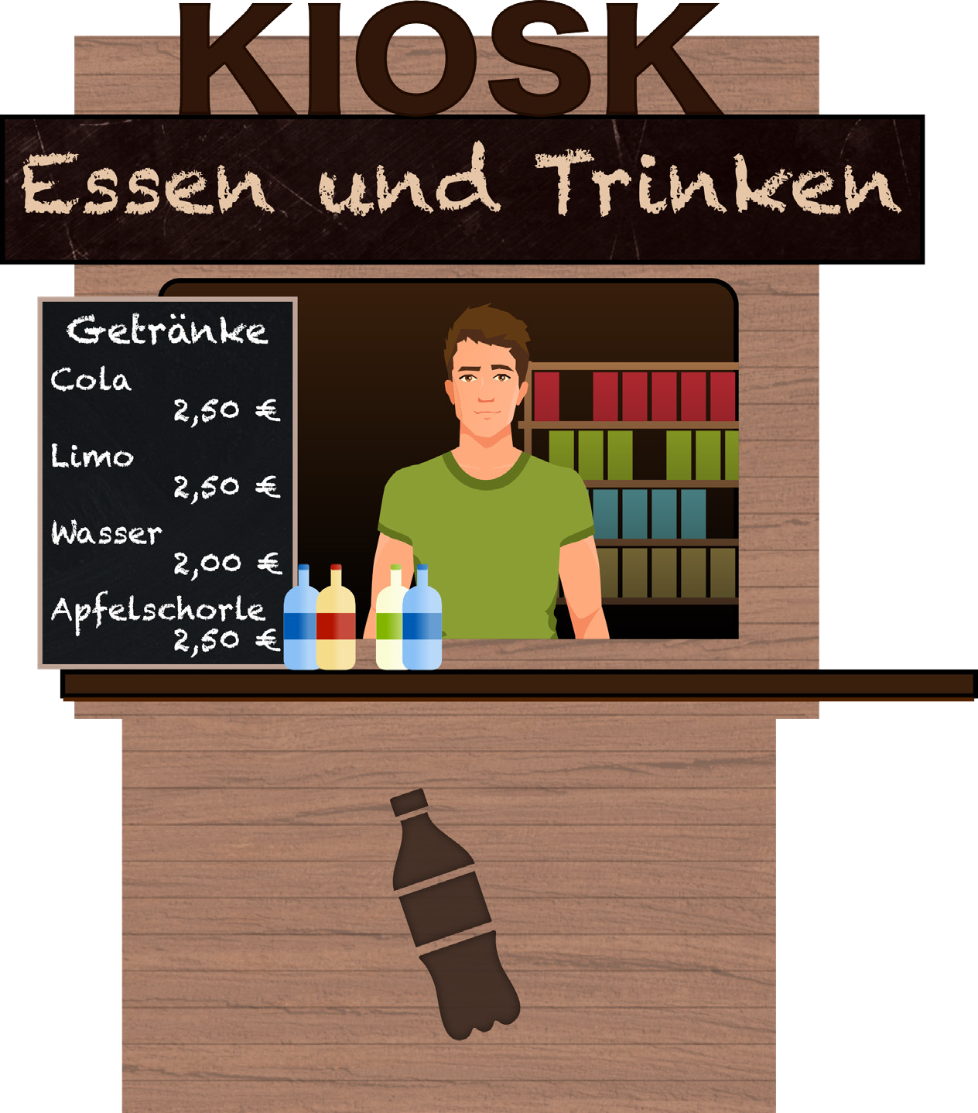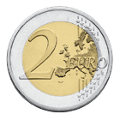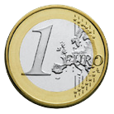

1 Cola und

1 Apfelschorle

**Wechselgeld**

**>>**

|  |  |  |  |  |  |  |  |  |  |  |  |  |  |  |  |  |  |  |  |  |  |  |  |  |  |  |  |  |  |  |  |  |  |  |
| --- | --- | --- | --- | --- | --- | --- | --- | --- | --- | --- | --- | --- | --- | --- | --- | --- | --- | --- | --- | --- | --- | --- | --- | --- | --- | --- | --- | --- | --- | --- | --- | --- | --- | --- |
|  |  |  |  |  |  |  |  |  |  |  |  |  |  |  |  |  |  |  |  |  |  |  |  |  |  |  |  |  |  |  |  |  |  |  |
|  |  |  |  |  |  |  |  |  |  |  |  |  |  |  |  |  |  |  |  |  |  |  |  |  |  |  |  |  |  |  |  |  |  |  |
|  |  |  |  |  |  |  |  |  |  |  |  |  |  |  |  |  |  |  |  |  |  |  |  |  |  |  |  |  |  |  |  |  |  |  |
|  |  |  |  |  |  |  |  |  |  |  |  |  |  |  |  |  |  |  |  |  |  |  |  |  |  |  |  |  |  |  |  |  |  |  |
|  |  |  |  |  |  |  |  |  |  |  |  |  |  |  |  |  |  |  |  |  |  |  |  |  |  |  |  |  |  |  |  |  |  |  |
|  |  |  |  |  |  |  |  |  |  |  |  |  |  |  |  |  |  |  |  |  |  |  |  |  |  |  |  |  |  |  |  |  |  |  |
|  |  |  |  |  |  |  |  |  |  |  |  |  |  |  |  |  |  |  |  |  |  |  |  |  |  |  |  |  |  |  |  |  |  |  |
|  |  |  |  |  |  |  |  |  |  |  |  |  |  |  |  |  |  |  |  |  |  |  |  |  |  |  |  |  |  |  |  |  |  |  |
|  |  |  |  |  |  |  |  |  |  |  |  |  |  |  |  |  |  |  |  |  |  |  |  |  |  |  |  |  |  |  |  |  |  |  |
|  |  |  |  |  |  |  |  |  |  |  |  |  |  |  |  |  |  |  |  |  |  |  |  |  |  |  |  |  |  |  |  |  |  |  |
|  |  |  |  |  |  |  |  |  |  |  |  |  |  |  |  |  |  |  |  |  |  |  |  |  |  |  |  |  |  |  |  |  |  |  |



34



Ordne die Getränke von der kleinsten Menge zur größten.

Nutze die Zeichen <, =, >.

**1**



Ordne die Getränke vom günstigsten Flaschenpreis zum teuersten.

Nutze die Zeichen <, =, >.

**2**



Vergleiche die Reihenfolge aus Aufgabe 1 und 2.

Was fällt dir auf?

Diskutiere mit deiner Partnerin oder deinem Partner.

**3**

Zahlen in Beziehung setzen

Du möchtest möglichst viel für dein Geld haben.

**Welches Getränk kaufst du?**

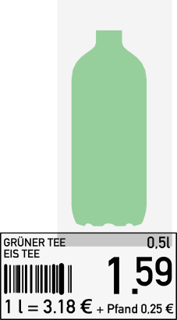

**A**



**B**

**C**

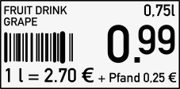

**D**



**E**

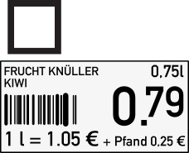

**F**



35



**b)** Ordne die Getränke nach diesem klein gedruckten Preis vom günstigsten zum teuersten. Nutze die Zeichen <, =, >.



Welches Angebot kaufst du?

Warum?

Diskutiere mit deiner Partnerin oder deinem Partner.

**5**

© logistock/stock.adobe.com

# Welches Getränk kaufst du?



**a)** Am Regal findest du einen klein gedruckten Preis. Was ist das?

**4**

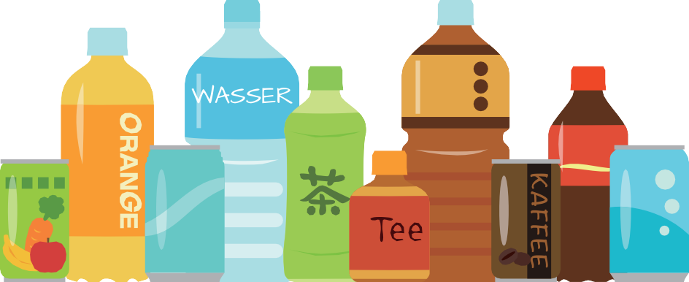

44



**1**

Probiere einen Schluck Wasser.

Was schmeckst du?



Schau dir die Flaschen genau an.

Was findest du heraus?

**2**



Bewerte: Welches Wasser trinkst du am liebsten?

**3**

Testen mit den Sinnen

**Schmeckt Wasser immer gleich?**

|  |  |  |  |  |
| --- | --- | --- | --- | --- |
|  |  |  |  |  |
| **Geschmack**  Wie schmeckt das Wasser? |  |  |  |  |
| **Sprudel**  Wie stark sprudelt das Wasser? |  |  |  |  |
| **Deine Wahl** Vergib Sterne für den Geschmack. |  |  |  |  |

|  |  |  |  |  |
| --- | --- | --- | --- | --- |
| **Marke** |  |  |  |  |
| **Inhalt** |  |  |  |  |
| **Welche Farbe hat die Flasche?** |  |  |  |  |
| **Welche Farbe hat das Wasser in der Flasche?** |  |  |  |  |